A

Project Report On

**Gym Management System**

##### for

**Royal Gym , Shirpur**

- Submitted by –

**Mr. Rohit H. Koli**

PRN-2020015400131143

[E-mail:kolirohit1252@gmail.com](mailto:kolirohit1252@gmail.com)

**-Guided by-**

Mr. Kedar Apte sir

-Submitted to-



**R. C. Patel Education Trust’s**

Institute of Management Research and Development, Shirpur

**-Affiliated to-**

**Kavayitri Bahinabai Chaudhari North Maharashtra University, Jalgaon**

Academic Year 2022-2023



Certificate

This is to certify that **Mr. Rohit Himmat Koli** has completed her project

entitled “Gym Management System” for partial fulfilment of **Bachelor of computer Application** (BCA) for Kavayitri Bahinabai Chaudhari North Maharashtra University (KBCNMU) , Jalgaon under our guidance during academic year 2022-2023.

This performance and the system are up to mark and we are satisfied with the same.

Mr. Kedar Apte Dr. Tushar R. Patel

Project Guide Head, Dept. of UG

Examiner 1:

Examiner 2:

Certificate

This is certifying that **Mr.Rohit Himmat Koli** student of R.C.Patel Institute of Management Research and Development, Shirpur. Has completed her project **"Gym Management System"** as a part of **BCA Sem-VI** in our organization. Her project work is satisfied and meets all requirements for computerization of our system. We wish them for their bright future.

**Name of the OWNER Royal Gym**

## DECLARATION

I am Rohit Himmat Koli, the student of the Bachelor of Computer Application (BCA) course in the Institute of Management Research & Development, Shirpur under K.B.C North Maharashtra University, Jalgaon.

I declared that the present report title ***“Gym Management System”***

is based on my project and it is genuine work. Thanking You.

Date:

Place:

**ACKNOWLEDGEMENT**

It is with great pleasure that I take this I have opportunity to head in respect and gratitude for those who helped me in making this project a get success.

I am thankful to our respected Director Prof. Dr. Vaishali B. Patil for supporting us in completion of project by granting many useful things.

The special acknowledgements to our HOD of UG Dept. Dr. Tushar R. Patel, for his timely suggestion, help, guidance and encouragements during the project.

I also thanks to my Project Guides Mr. Kedar Apte who supports me and guide me in completion of my project report in successful manner.

I also thank to all who indirectly help me in completion of my report and obligate and great hands in behind my achieving goals.

**Mr. *Rohit Koli***

**INDEX**

|  |  |
| --- | --- |
| **1.Introduction** | **7** |
| 1.1 Introduction to project | 8 |
| 1.2 About organization | 8 |
| **2.Need of system** | **9** |
| **3.System study analysis** | **11** |
| 3.1 Objective of proposed system | 12 |
| 3.2 Scope of proposed system | 12 |
| 3.3 Existing system Overview | 13 |
| 3.4 Drawback and limitation of system | 13 |
| **4.Feasibility study** | **14** |
| 4.1 Information gathering | 15 |
| 4.2 Economic feasibility study | 15 |
| 4.3 Technical feasibility study | 16 |
| 4.4 Operational study | 16 |
| **5.System development** | **17** |
| 5.1 Operating environment | 18 |
| 5.2 Introduction of technology | 18 |
| 5.3 Introduction of database | 19 |
| **6.Detail design of proposed system** | **20** |
| 6.1 Data Flow Diagram | 21 |
| 6.2 Entity Relationship Diagram | 26 |
| **7.Screenshots** | 28 |
| **8.Coding system** | 41 |
| **9.Testing and implementation** | 43 |

|  |  |
| --- | --- |
| 9.1 Testing | 44 |
| 9.2 Types of testing | 45 |
| **10.Conclusion and remark** | 46 |
| **11.Bibliography** | 48 |

# CHAPTER 1: INTRODUCTION

### Introduction

An Gym Management System is an web based Application with which the Gym Owner Can store information about their gym and persons who are related with gym and track data for smooth functioning of the organization.

This application is simple to understand and can be used by anyone who is not even familiar with simple gym system. It is user friendly and just asks the user to follow step by step operations by giving him Few options.

### About Organization

Royal Gym, Shirpur is One of the premium gym run by Harpal Rajput. Royal Gym is best unisex gym in overall Dhule district.

It has energetic and inviting atmosphere and peoples are also supportive.

This system is created for maintain the record of all employees of the collage.

# CHAPTER 2: NEED OF STUDY

### Need of Study

* + - To maintain individual user records of gym users.
    - Providing proper Technical Assistance to the User.
    - Providing Online Help.
    - Benefits of promoting new services the organization can gain.
    - To increase the global market.
    - To record information about every Customer.
    - As the era of internet has emerged as one of the advertising media, we decide to attract different customers through marketing on the interactive internet website.

# CHAPTER 3: SYSTEM STUDY ANALYSIS

## System Analysis

System analysis aims at establishing requests for the system to be acquired, developed and installed. It involves studying and analyzing the ways of an organization currently processing the data to produce information. Analyzing the problem thoroughly forms the vital part of the system study. In system analysis, prevailing situation of problem carefully examined by breaking them into sub problems. Problematic areas are identified and information is collected. Data gathering is essential to any analysis of requests. It is necessary that this analysis familiarizes the designer with objectives, activities and the function of the organization in which the system is to be implemented.

### Objectives of proposed system

* + - Development of rich web based **Gym Management System** .
    - **Gym Management System** is developed for smooth working of Admin and Customer.
    - This Website is fully integrated with Customer and Admin Relationship Management and Developed in a manner that is easily manageable, time and cost saving that shows relieving one from manual works.
    - **Gym Management System** provides automated technical screening, computerized work, and intellectual evaluation to conduct recruitment.
    - To provide the facility of Database Structure capable of holding an unlimited number of customers.
    - To provide more facility and feasibility to customers.

### Scope of proposed system

The scope of the Gym Management System is as follows:

This is one integrated system that contains both the user component and the Admin component. There are features like User can add education, order add experience, update there information very easily.

To overcome drawbacks of existing system, the proposed computerized system has following provisions:

1. Maintaining detail record of Customers, personal details etc.
2. Maintaining the proper record of Customers.
3. Keeping the record of employee with complete details
4. Maintaining relationship between all of objects of the system.

The main objective of the computerized system is to provide correct information of every aspect in the correct form at the correct time with accuracy and reliability.

### Existing System Overview

* Maintain easily records of Customers manually.
* Customers can Add, Update, Delete records manually.
* Customers easily insert information in system.
* Easy to understand for new user.
* Only authenticate user can log-in the system.
* Administrator can maintain all record manually.

### Limitation of System

* + - Cannot see design page preview like .aspx page. Every time want to run then see the design.
    - Understanding flow of application is very hard one. It is little bit of complex to implement and not suitable for small level applications.
    - Its deployment is little bit hard one.
    - Complex Pages with Performance issues.
    - The managed code can be slower than native code.
    - Migrating applications to .NET can be expensive.

# CHAPTER 4: FEASIBILITY STUDY

## Information Gathering

The main aim of fact-finding techniques is to determine the information requirements of an organization used by analysts to prepare a precise SRS understood by user.

Ideal SRS Document should −

* + - Be complete, Unambiguous, and Jargon-free.
    - Specify operational, tactical, and strategic information requirements.
    - Solve possible disputes between users and analyst.
    - Use graphical aids which simplify understanding and design.
    - There are various information gathering techniques −

##### Interviewing

Systems analyst collects information from individuals or groups by interviewing. The analyst can be formal, legalistic, play politics, or be informal; as the success of an interview depends on the skill of analyst as interviewer.

##### Questionnaires

This method is used by analyst to gather information about various issues of system from large number of persons.

##### Review of Records, Procedures, and Forms

Review of existing records, procedures, and forms helps to seek insight into a system which describes the current system capabilities, its operations, or activities.

##### Observation

This is a method of gathering information by noticing and observing the people, events, and objects. The analyst visits the organization to observe the working of current system and understands the requirements of the system

## Economic Feasibility Study

Economic analysis is most frequently used for evaluation of the effectiveness of the system. More commonly known as cost/benefit analysis the procedure is to determine the benefit and saving that are expected from a system and compare them with costs, decisions is made to design and implement the system. This part of feasibility study gives the top management the economic justification for the new system. This is an important input to the management the management, because very often the top management does not like to get confounded by the various technicalities that bound to be associated with a project of this kind. A simple economic analysis that gives the actual comparison of costs and benefits is much more meaningful in such cases.

## Technical Feasibility Study

Technical feasibility assesses the current resources (such as hardware and software) and technology, which are required to accomplish user requirements in the software within the allocated time and budget. For this, the software development team ascertains whether the current resources and technology can be upgraded or added in the software to accomplish specified user requirements. Technical feasibility also performs the following tasks.

* Analyses the technical skills and capabilities of the software development team members.
* Determines whether the relevant technology is stable and established.
* Ascertains that the technology chosen for software development has a large number of users so that they can be consulted when problems arise or improvements are required.

## Operational Feasibility Study

Operational feasibility assesses the extent to which the required software performs a series of steps to solve business problems and user requirements. This feasibility is dependent on human resources (software development team) and involves visualizing whether the software will operate after it is developed and be operative once it is installed. Operational feasibility also performs the following tasks.

It is Operational feasible, since the system is providing an attractive user interface to the operator/end user, so he feels very easy to work onto it. Response to operator/end user is very fast and very good. Since, as we mentioned above that it requires much less amount of cost, it uses computer work so it is very fast to operate and it is very easy for user to work on it.

# CHAPTER 5: SYSTEM DEVELOPMENT

## Operating Environment

A major element in building system is selection of compatible hardware & software. Hardware selection they begin with requirements analysis following by a request for proposal, evaluation & validation, post installation review.

While selecting the software various criteria is considered such as reliability (gives consistent results), functionality (function to standards), capacity (satisfies volume requirements), flexibility (adapts to changing needs), usability (user friendly), security (to prevent unauthorized access), performance (capacity to deliver as expected), serviceability (good documentation), minimal cost (affordable for intended application).

##### Software Requirement:

1. Operating System-widows 11
2. Wamp / Xamp server.

##### Hardware Requirement:

1. Intel Core i3.
2. Minimum 4GB RAM.
3. Input Devices: Keyboard, Mouse.

## Introduction of Technology (About Front End)

PHP:-

PHP stands for PHP: Hypertext Preprocessor PHP is a server-side scripting language,like ASP PHP scripts are executed on the server

PHP supports many databases (MYSQL, Informix, Oracle , Sybase, Solid, Generic ODBC, etc.)

PHP is an open source software. PHP is free to download and use .

CSS

Cascading Style Sheets (CSS) Simple mechanism

Easy for adding style (e.g., fonts, colors, spacing) to Web documents.

## Introduction to Database

MYSQL

MYSQL is a database server

MYSQL is ideal for both small and large applications MYSQL supports MYSQL standard SQL .

MYSQL compiles on a number of platforms. MYSQL is free to download and use.

# CHAPTER 6: DETAIL DESIGN

* 1. **Data Flow Diagram**
     + Data flow diagram is graphical tool which is used to describe and analyse the movement of data through a system. They focus on the data flowing into the system, between processes and in & out of data stores.
     + DFD is a graphical technique that detects information flow and transformation that are applied as data move from input and output.
     + DFD is a central tool and the basis from which other components are developed.
     + DFD provides mechanism for a final modelling as well as information flow modelling.
     + DFD has very simple notation which are easily understood by the users & those who involved in the system.

Symbol used for DFD

*Symbol Meaning*

External Entity as source

Destination.

Process or Function.

Indicates the direction of Data flow.

##### Entity Relationship Diagrams:

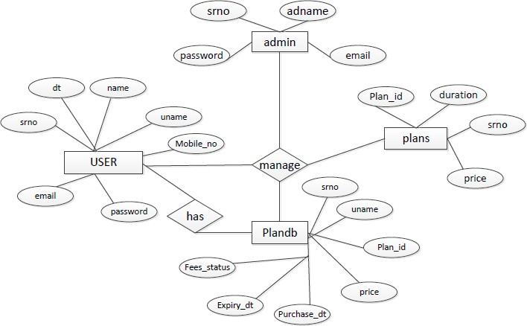

DFD:-

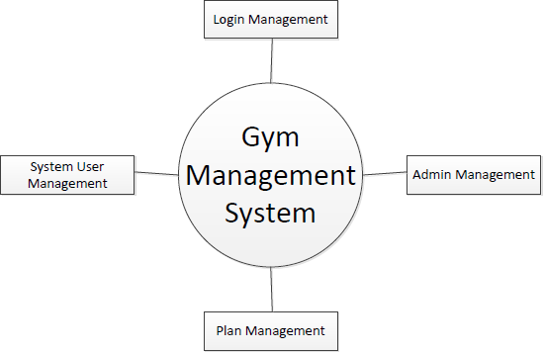

# CHAPTER 7 SCREENSHOTS

#### Registration page

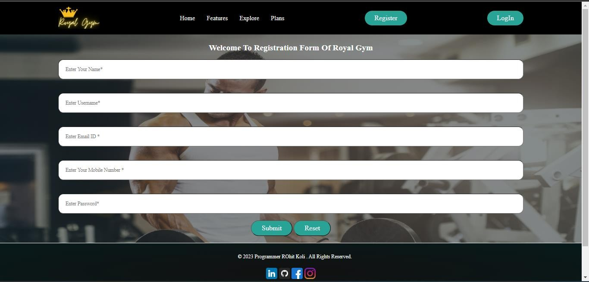

**User login page**

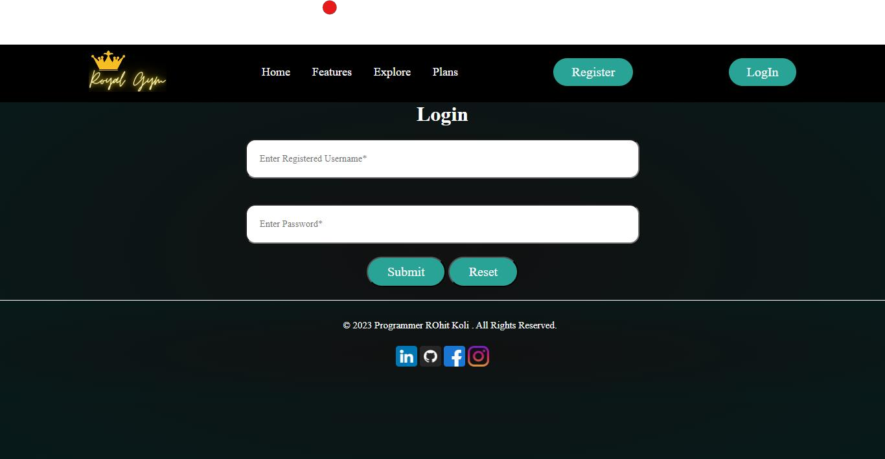

#### Admin login page



**Customer Information Page**

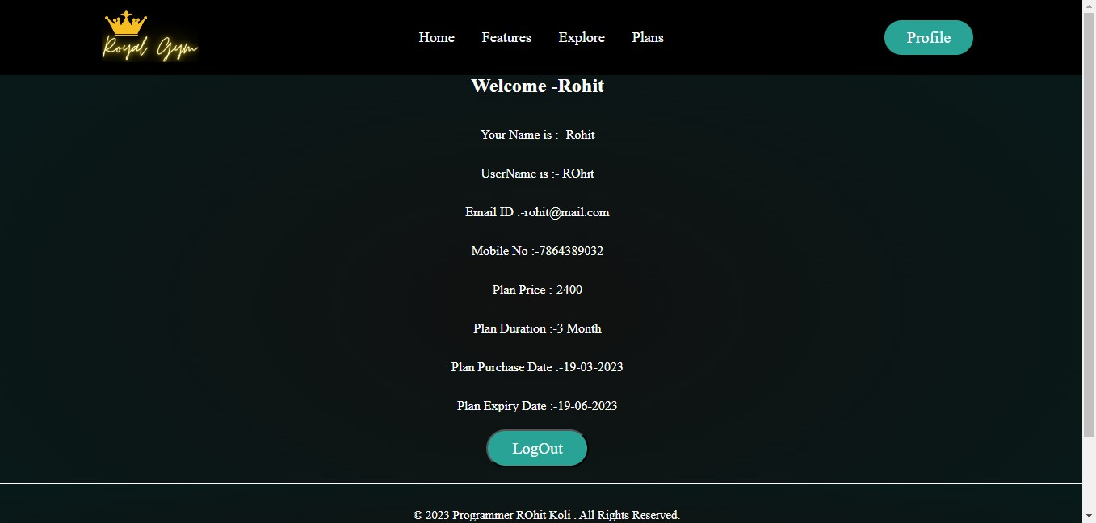

**Admin Dashboard**

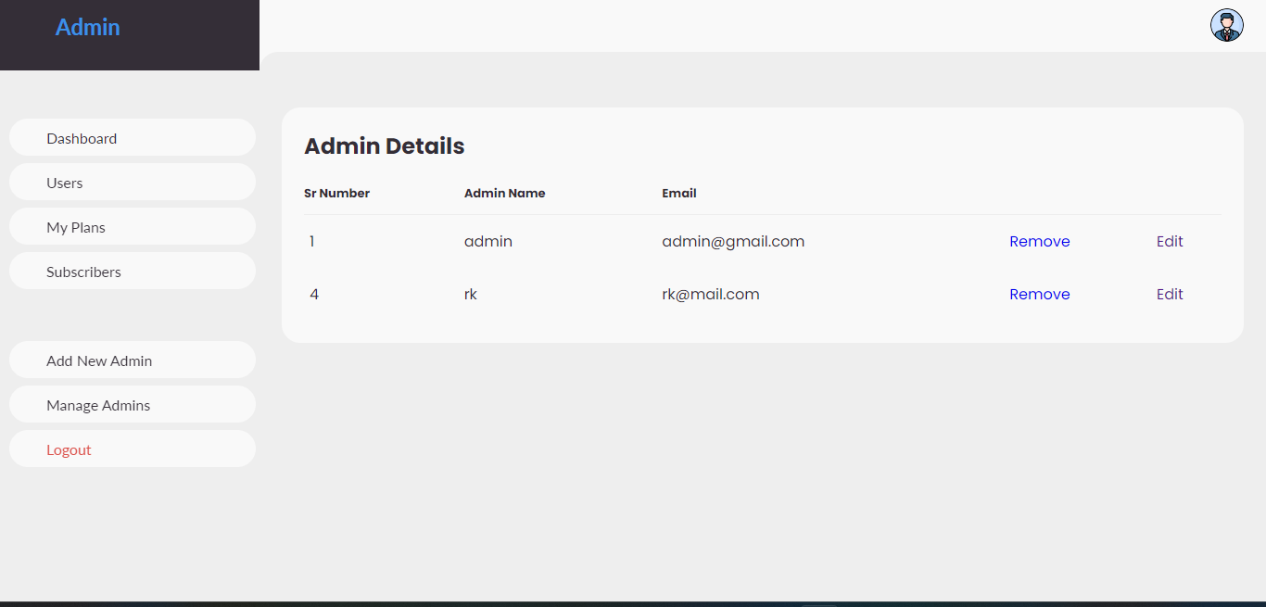

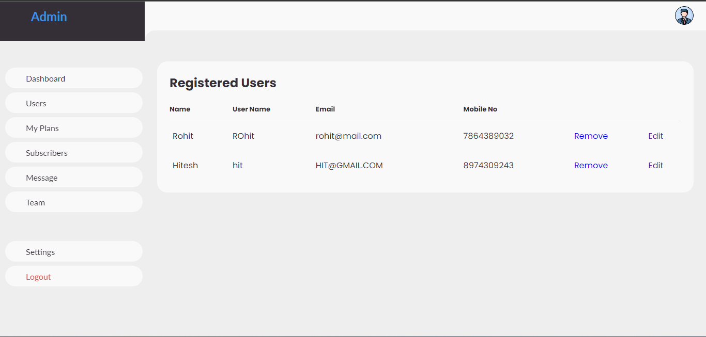

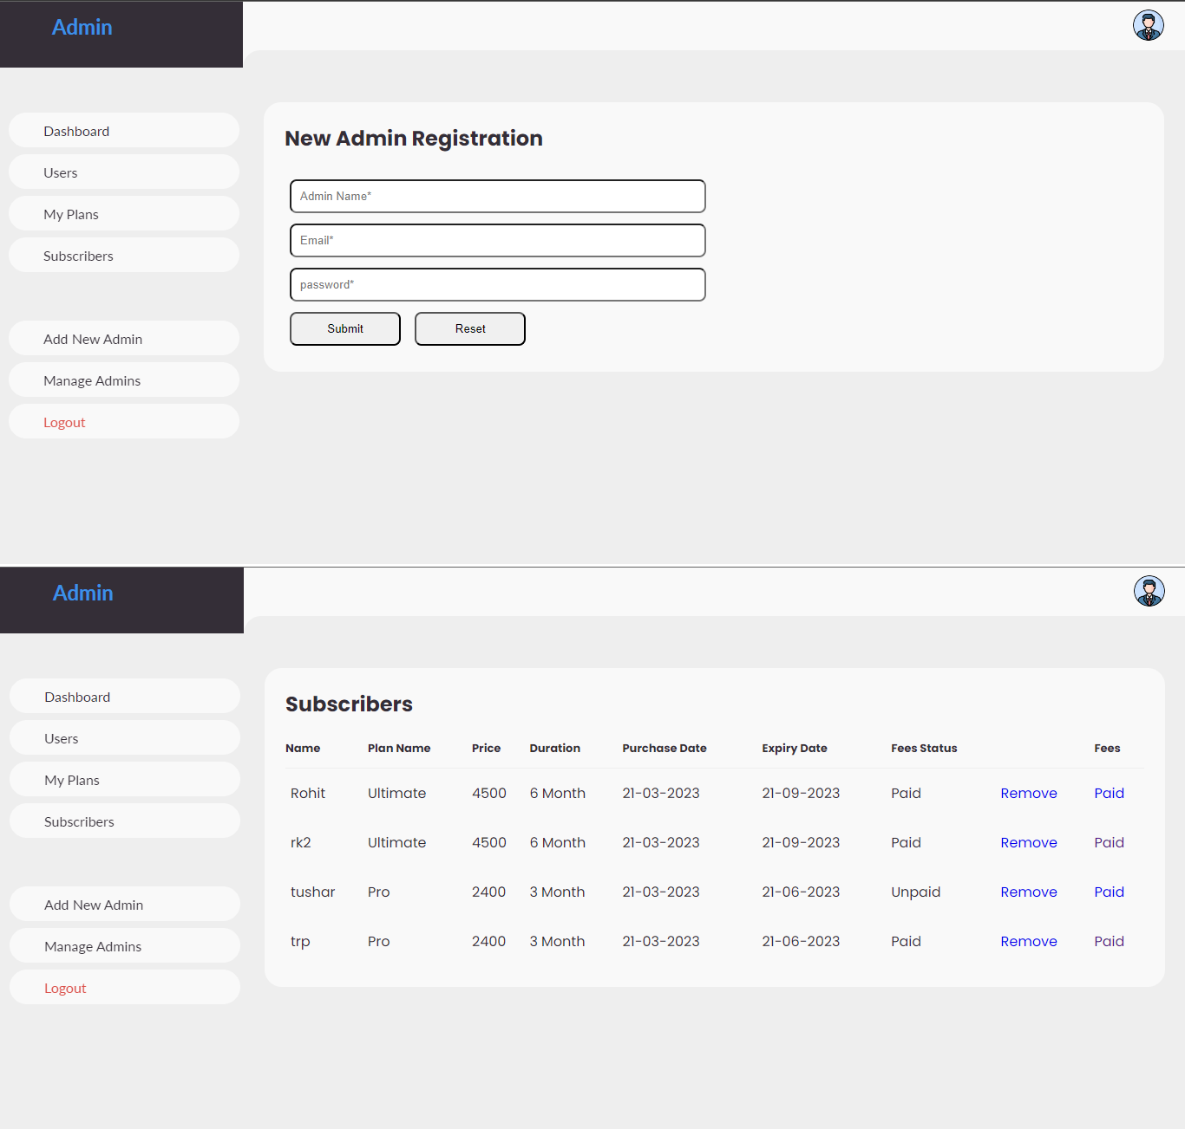

**Database Design**

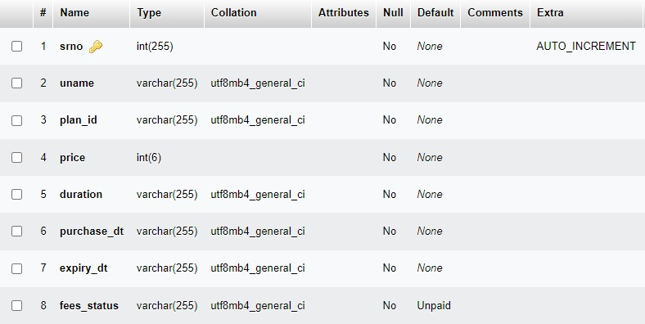**Plandb:-**

## Userdb:-

##### Admindb:-

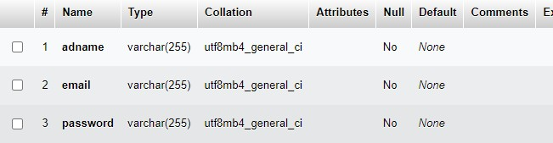

**plans**

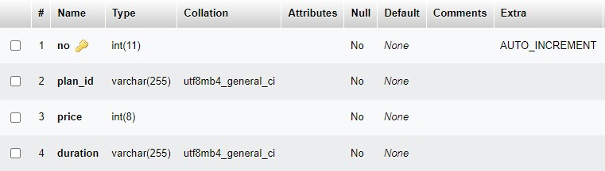

# CHAPTER 8: CODING

### Coding

A code is an ordered collection symbols to provide

unique identification of data. Codes can be used by people who do not with data processing; the following are characters of a good code generation. Characteristics of good coding are

* + - * Uniqueness
      * Meaningfulness
      * Stability
      * Uniform Size and Format
      * Simplicity
      * Conciseness
      * Versatility

The goal of the coding or programming phase is to translate the design of the system produced during the design phase into code in a given programming language, which can be executed by a computer and that performs the computation specified by the design. The coding phase affects both testing and maintenance profoundly. As we saw earlier, the time spent in coding is a small percentage of the total software cost, while testing and maintenance consume the major percentage. Thus, it should be clear the goal during coding should not be to reduce the implementation cost, but the goal should be to reduce the cost of later phases, even if it means that the cost of this phase has to increase. In other words, the goal during this phase is not to simplify the job of the programmer. Rather the goal should be to simplify the job of the tester and the maintainer.

# CHAPTER 9:

TESTING AND IMPLEMENTATION

## Testing

Testing of website perform coding like validation and verification testing. Different testing tools are used for testing like white box testing and black box testing.

Basic tools used to test this project are:

* + 1. Black Box Testing.
    2. White Box Testing.
    3. GUI Testing.

## Type of Testing

#### Black Box Testing:

It is a method of software testing that tests the functionality of an application as opposed to its internal structures or workings. Specific knowledge of the application’s code/internal structure and programming language in general is not required. The tester is only aware of what the software is supposed to do, but not how i.e., when he enters a certain input, he gets certain output; without being aware of how the output was produced. Tests cases are built around specifications and requirements, i.e., what the application is supposed to do. It uses external descriptions of the software, including specifications, requirements and designs to derive test cases. These test designers select valid and invalid inputs and determine the correct output. There is knowledge of the test object’s internal structure.

This method of test can be applied to all levels of software testing: Unit, Integration, System and Acceptance. It typically comprises most if not all testing at higher levels, but can also dominate unit testing as well.

#### The advantages of this type of testing include:

* The test is unbiased because the designer and the tester are independent of each other.
* The tester does not need knowledge of any specific programming languages.
* The test is done from the point of view of the user, not designer.

#### The disadvantages of this type of testing include:

* The case can be redundant if the software designer has already run a test case.
* The test cases are difficult to design

#### White Box Testing:

White box testing is a method of testing software that tests internal structures or workings of an application, as opposed to its functionality. In white-box testing an internal perspective of the system, as well as programming skills, are required and used to design the test cases. The tester chooses input to exercise paths through the code and determine the appropriate outputs. While white-box testing can be applied at the unit, integration and system levels of the software testing process, it is usually done at unit level. It can test paths within a unit, paths between units during integration, and between subsystems during a system level test. Though this method of test design can uncover many errors or problems, it might not detect unimplemented parts of the specification or missing requirements.

#### White-Box test design techniques include:

* + Control flow Testing
  + Data flow Testing
  + Branch Testing
  + Path Testing

#### Graphical User Interface Testing:

It is the process of testing a product’s graphical user interface to ensure it meets its written specifications. This is normally done through the use of a variety of test cases. It checks only the user friendliness. The creation of the user interface is less time consuming for the user but more complex for the programmer. It must be tested for its sole purpose.

#### This test must be carried out to ensure:

* + Windows open properly.
  + All data contents are properly addressable.
  + All the graphical elements are available and displayed. Multiple or incorrect mouse click do not produce side effects.

# CHAPTER 10: CONCLUSION AND REMARK

#### Conclusion

In our project work, an attempt has been made to develop an Gym Management System web site. We develop this project that helps the people and make them aware that their information is stored securely To establish this website we use various methodologies. To develop this project we have faced many problem but we hardly tried to develop this project. Our supervisor helps us by giving his valuable opinion, decision and time.

#### I hereby conclude by stating some salient features:

1. The whole project is menu driven, which enables the user to handle the system without any difficulty.
2. The input screen designed in a simple manner and associated with proper messaged and prompt so that the user can easily enter the data.
3. All forms have proper validations.
4. Computerization speeds up the processing, user-friendly interface.
5. Reports are available by just selecting the option in a main menu.

# CHAPTER 11: BIBLIOGRAPHY

**References:**

Websites: - [https://www.w3cschool.com](https://www.w3cschool.com/) [https://www.youtube.com](https://www.youtube.com/) [https://www.google.com](https://www.google.com/)